ROWNUM Search

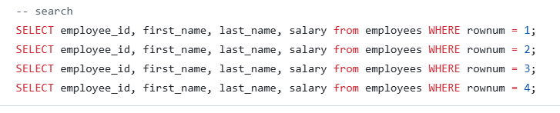

Why ROWNUM =1 return first row but ROWNUM =2 does not return second row? and why ROWNUM <=8 return first 8 rows correctly?
The answer is: Oracle assigns ROWNUM starting from 1, in the order rows are returned.
So why ROWNUM = 2 returns no rows?
SELECT *
FROM employees
WHERE ROWNUM = 2;

Step-by-step execution:
Oracle fetches the first row
Assigns it ROWNUM = 1
Applies the condition ROWNUM = 2
❌ Row is rejected
Oracle cannot assign ROWNUM = 2 because no row with ROWNUM = 1 passed the filter

- Conclusion :
ROWNUM must start at 1
If row 1 is filtered out, row 2 is never created.

- Why ROWNUM < 2 or ROWNUM <= 2 works
SELECT *
FROM employees
WHERE ROWNUM <= 2;
Execution:
First row → ROWNUM = 1 → passes condition
Second row → ROWNUM = 2 → passes condition
Rows are returned successfully
- Why ROWNUM > 1 also returns no rows
SELECT *
FROM employees
WHERE ROWNUM > 1;
Execution:
First row → ROWNUM = 1
Condition (1 > 1 )fails
Oracle never creates ROWNUM = 2

